**\*Team name 队伍名称**

Team#6 炼丹西游 Alchemy for The Journey to the West

**\*Product direction 产品方向**

DeFi，Metaverse，NFTs  
去中心化金融，稳定币，元宇宙Metaverse，NFT

**《炼丹西游》可能是首个中华西游文化IP+DeFi+Metaverse+NFT的项目。**

《Alchemy for The Journey to the West》 is the first project which merges DeFi, Metaverse, NFT and the Chinese elements in Journey to the West.

[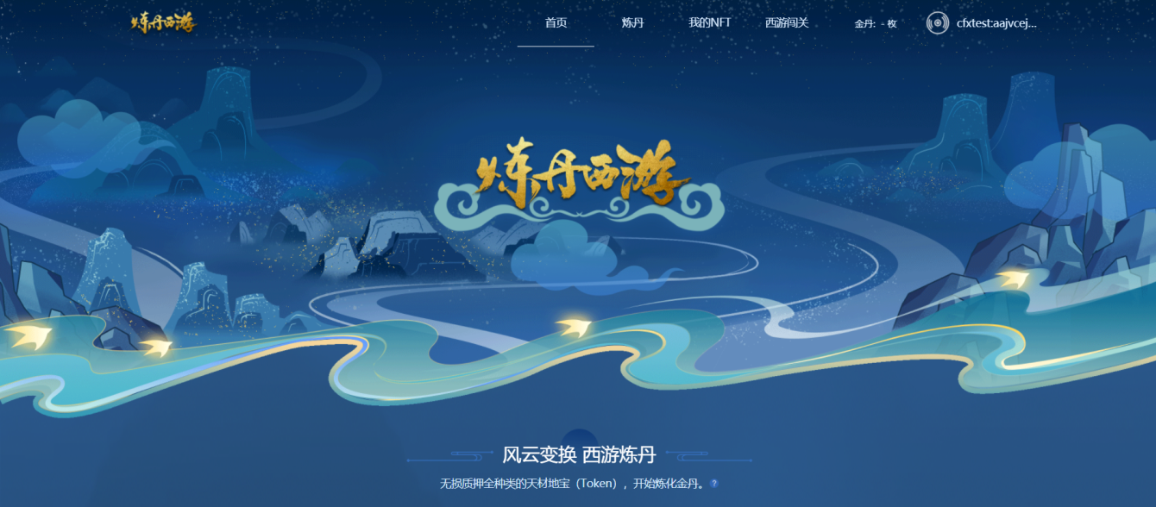](https://user-images.githubusercontent.com/1519538/127728772-a9ef386f-91c0-496f-9952-4eeb3e034bed.png)

**\*Introduction 介绍**

1、现在区块链的常见DeFi玩法，每种Token需要单独建立池子，单独操作。大家拥有的区块链数字资产种类越来越多，操作越来越繁琐。很多体量不够大的资产往往没有无损挖矿的渠道，一些小额资产大家也懒得专门折腾质押。我们首创炼丹新玩法：很**多种资产可以同时质押到一个炼丹炉（首创）内获得金丹，好管好玩收益更高。同时设计了轮回机制（首创）**，让金丹有可能成为一个稳中微涨的稳定币。  
2、中国四大名著中，红楼梦、水浒传、三国演艺、西游记都有经典连环画，我们有计划将它们以NFT的形式做成高清数字收藏版。对于西游记很多朋友会有个疑问：九九八十一难没有看全过，总感觉少了一些。所以我们将新绘制一套按照八十一难的西游戏绘画并发行NFT，从新的角度重温取经记忆，弘扬中华文化。全套预计上千张，构成**西游元宇宙Metaverse**，与其他元宇宙项目（山海经，古国，小小，Kaka等）会有互动。  
3、Conflux树图区块链是我们现在看到的最有可能是”对“的公链。区块链项目选择Conflux作为底层，未来就成功了一半。Conflux做Layer2也是足够的。（这里不想写参数和推荐，资料自查即可。开发者们一旦在Conflux上做过项目后，基本就会留在Conflux。各种优势相对极大）  
4、前三点相结合，形成了炼丹西游。详见下方设计文档超链接。

1、In the common design of DeFi, each token needs a seperate pool for staking and other operation. As blockchain assets get more various, users are facing more and more complex operations. Many assets of small amount may not have no-loss mining channels and users usually would not like to spend time and energy staking tokens of a small amount. Therefore, we innovated a new rule of Alchemy: users can stake multiple different tokens to the same Furnace to get Jindan. Users will get higher profit with this simple and interesting rule. And we designed a reincarnation mechanism to make Jindan a stablecoin with a sligt rise. The Furnace for different tokens and the reincarnation mechanism is an innovation in the DeFi world.  
2、There are very classic comics of the Four Chinese Masterpieces -- Dream of Red Mansions, Outlaws of the Marsh, the Three Kingdoms, and Journey to the West. We are planning to make high definition digital versions of them in the form of NFT for collection. Tang Monk and his apprentices got through 81 adversities. It very easy for audience to miss some of the 81, so we will design a series of artworks according to the 81 adversities and issue NFTs to review the memory of classics and carry forward Chinese culture in a new form. We are planning over a thousand pieces of NFTs to structure the Metaverse of the Journey to the West, and there will be interactions with other metaverse projects such as the Classic of Mountains and Rivers, Ancient State, Mini World and Kaka (these projects are under development now).  
3、Conflux Tree-Graph blockchain is the public chain most likely represent the future direction of blockchain in our view. A blockchain project choosing Conflux as its infrastructure is on the half way to success. (Documents about Conflux is accessible to everyone on the Internet. Specific data and special recommendation are not needed here. Developers who have developed projects on Conflux will probably choose to stay on it, so it is an advantage for Conflux projects.)  
4、Alchemy for the Journey to the West is formed based on the previouse background. Detailed design draft is in <https://shimo.im/docs/MckfpPvob24utxqV/>

[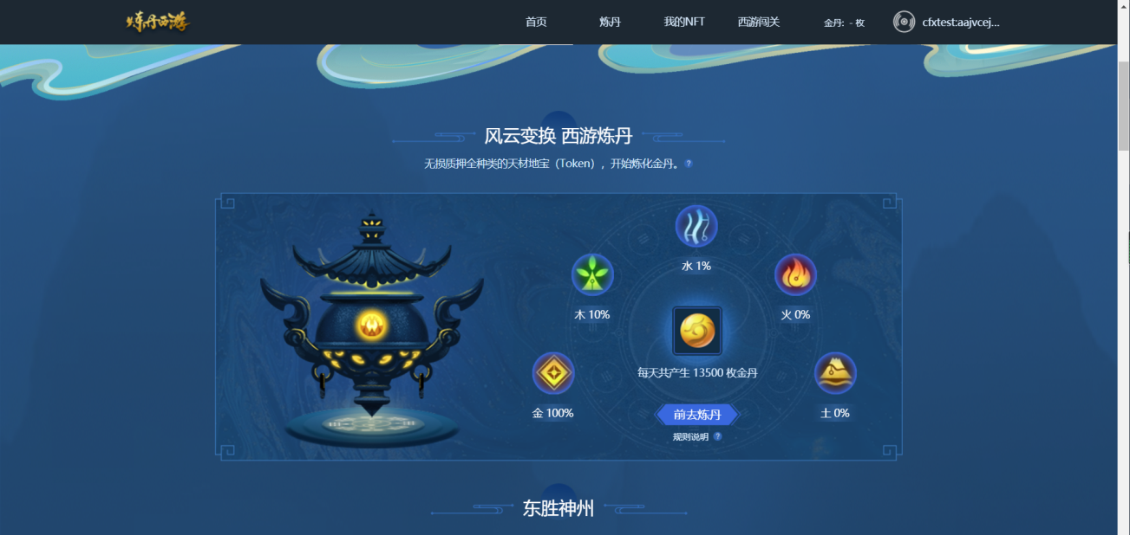](https://user-images.githubusercontent.com/1519538/127728780-ac75c631-f3e5-4329-ae77-5e4840baddb0.png)

**\*Github link 项目目录链接**

<https://github.com/chy2021/Layer2Hackathon/tree/main/projects/Team-6-%E7%82%BC%E4%B8%B9%E8%A5%BF%E6%B8%B8%20Alchemy%20for%20The%20Journey%20to%20the%20West/Kalpa.Contract.HKS>

[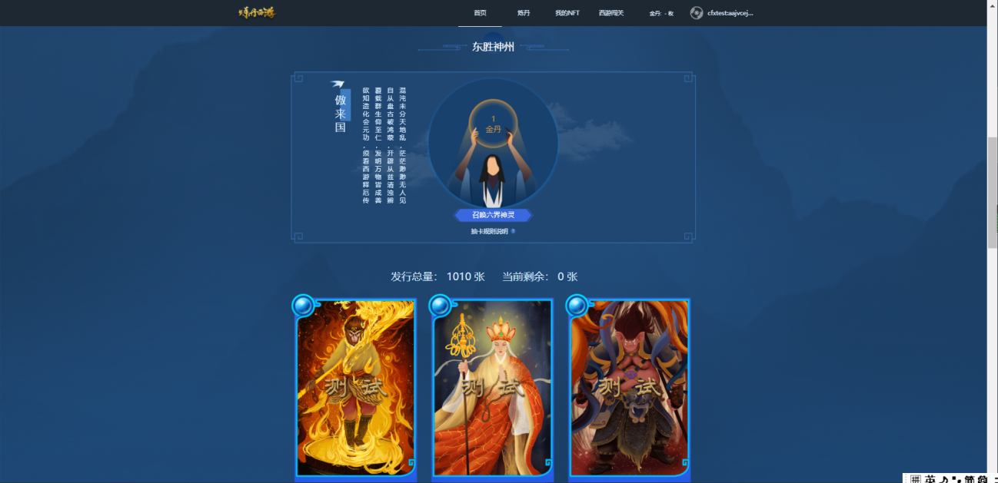](https://user-images.githubusercontent.com/1519538/127728794-86c3fbe1-926a-4eaf-abba-2756534e9973.png)

**\*Demo link 演示链接**

我们将部署在Conflux测试网上，可以使用Conflux Portal获取测试代币。  
<http://test.dan.finance/>  
需要使用Conflux树图区块链测试网和Conflux官方插件钱包Portal访问。  
With Conflux Testnet, Portal

The website is deployed on the Conflux testnet. Users can get test tokens through the faucet of Conflux Portal.  
Users can access the website with Conflux testnet and Conflux Portal.

[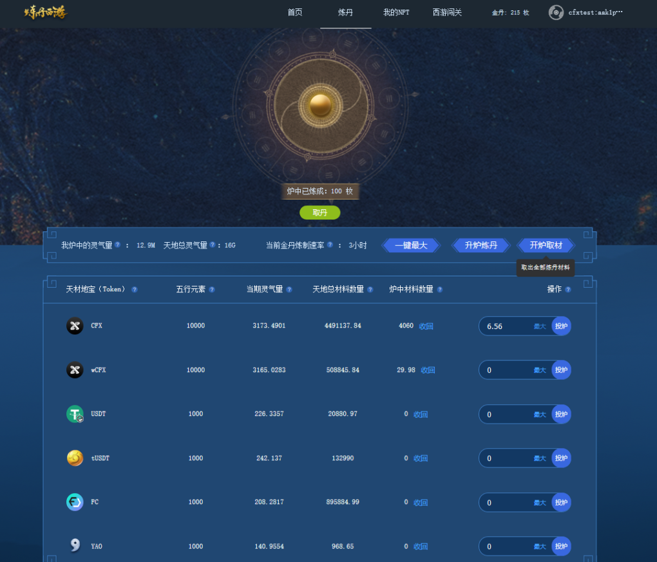](https://user-images.githubusercontent.com/1519538/127728814-2f5fa9df-5dc5-442d-a832-d01b41feef6a.png)

**\*Ethereum Wallet Address 钱包地址**

以太坊钱包：0x237030758c5468dAC2181b9a59C4631a527948Ee  
我们更偏爱Conflux树图区块链钱包，如果可以的话  
We prefer Conflux wallet if possible.  
Conflux Wallet Address  
树图钱包 cfx:aaskwa73j9c8mdh1x0cege9crnykbvta9etx2mprsy

**Documentation 文档**

设计草稿如下：Design draft  
<https://shimo.im/docs/MckfpPvob24utxqV/> 《炼丹西游设计文档-IOSG黑客松》

**Twitter handle 推特**

因网络环境，不宜使用推特。我们使用可以全世界访问到的论坛，微博，微信，QQ等。  
本项目主要使用论坛<https://forum.conflux.fun/>  
团队成员昵称为：chy,acuilab,毛毛硕,brander,vitec.,George。

Twitter is not recommanded due to the network environment. We are using the Forum, Weibo, Wechat, QQ and other tool accessible to the whole world to communicate with users.  
Conflux Forum <https://forum.conflux.fun/> is the main channel.  
The user name of our team members on the Forum: chy, acuilab, 毛毛硕, brander, vitec. and George.

**Website 网站**

部署在Conflux测试网上，可以使用Conflux Portal获取测试代币。  
<http://test.dan.finance/>  
需要使用Conflux树图区块链测试网和Conflux官方插件钱包Portal访问。  
With Conflux Testnet, Portal

The website is deployed on the Conflux testnet. Users can get test tokens through the faucet of Conflux Portal.  
Users can access the website with Conflux testnet and Conflux Portal.

**Team information 团队信息**

Conflux Community 树图区块链爱好者社区 Community of Tree-Graph blockchain fans  
[ chy ] 运营和编辑 Operator and editor  
[ acuilab ] 后端开发 Back-end developer  
[ Vitec. ] 合约开发和后端开发 Smart contract developer and back-end developer  
[ 毛毛硕 ] 项目经理和前端开发 Project manager and front-end developer  
[ 宇智波斑 ] 合约开发和后端开发 Smart contract developer and back-end developer  
[ 周George ] 产品经理 Product manager

欢迎在Conflux社区找到区块链未来的答案：汇流。  
Welcome to find the key to the future of blockchain in our community -- Conflux.  
<https://confluxnetwork.org/>  
<https://123cfx.com/>  
<https://forum.conflux.fun/>